**React**

**11. ReactJS-HOL - Create a React Application “eventexamplesapp” to handle various events of the form elements in HTML.**

**CODE:**

**Src 🡪 components**

**CurrencyConvertor.js**

import React, { useState } from 'react';  
  
function CurrencyConvertor() {  
 const [amount, setAmount] = useState('');  
 const [currency, setCurrency] = useState('Euro');  
  
 const handleSubmit = () => {  
 const euroToInr = 80;   
 if (currency === 'Euro') {  
 const converted = parseFloat(amount) * euroToInr;  
 alert(`Converting to Euro Amount is ${converted}`);  
 }  
 };  
  
 return (  
 <div style={{ marginTop: '30px', padding: '20px' }}>  
 <h2 style={{ color: 'green' }}>Currency Convertor!!!</h2>  
  
 <div style={{ marginBottom: '10px' }}>  
 <label style={{ marginRight: '10px' }}>Amount:</label>  
 <input  
 type="number"  
 value={amount}  
 onChange={(e) => setAmount(e.target.value)}  
 />  
 </div>  
  
 <div style={{ marginBottom: '10px' }}>  
 <label style={{ marginRight: '10px' }}>Currency:</label>  
 <select  
 value={currency}  
 onChange={(e) => setCurrency(e.target.value)}  
 >  
 <option value="Euro">Euro</option>  
 </select>  
 </div>  
  
 <button onClick={handleSubmit}>Submit</button>  
 </div>  
 );  
}  
  
export default CurrencyConvertor;

**App.js**

import React from 'react';  
import './App.css';  
import CurrencyConvertor from './components/CurrencyConvertor';  
  
class App extends React.Component {  
 constructor(props) {  
 super(props);  
 this.state = {  
 counter: 0  
 };  
 }  
  
 increment = () => {  
 this.setState({ counter: this.state.counter + 1 });  
 this.sayHello();  
 };  
  
 decrement = () => {  
 this.setState({ counter: this.state.counter - 1 });  
 };  
  
 sayHello = () => {  
 console.log("Hello! Counter button clicked.");  
 alert("Hello! This is a static message.");  
 };  
  
 sayWelcome = (message) => {  
 alert(message);  
 };  
  
 handleClick = (event) => {  
 alert("I was clicked");  
 console.log(event);  
 };  
  
 render() {  
 return (  
 <div className="App">  
 <h1>React Events Example</h1>  
 <h2>Counter: {this.state.counter}</h2>  
 <button onClick={this.increment}>Increment</button>  
 <button onClick={this.decrement}>Decrement</button>  
 <button onClick={() => this.sayWelcome("Welcome!")}>Say Welcome</button>  
 <button onClick={this.handleClick}>OnPress</button>  
  
 <CurrencyConvertor />  
 </div>  
 );  
 }  
}  
  
export default App;

**OUTPUT:**

**Increment Button**

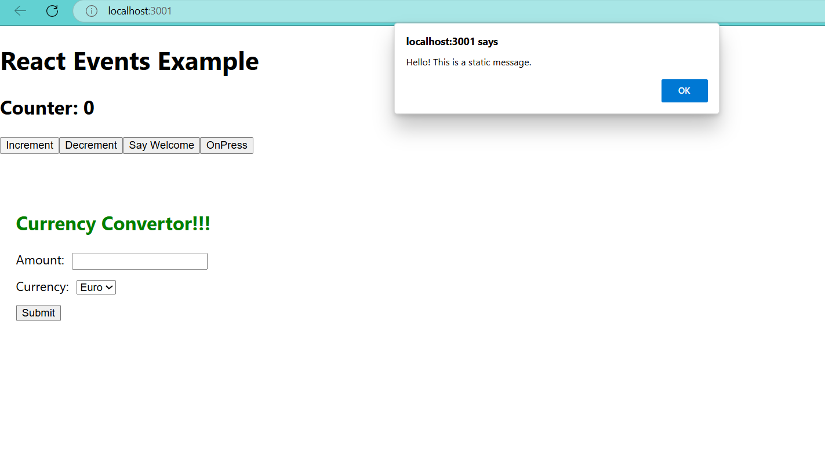

**Decrement Button**

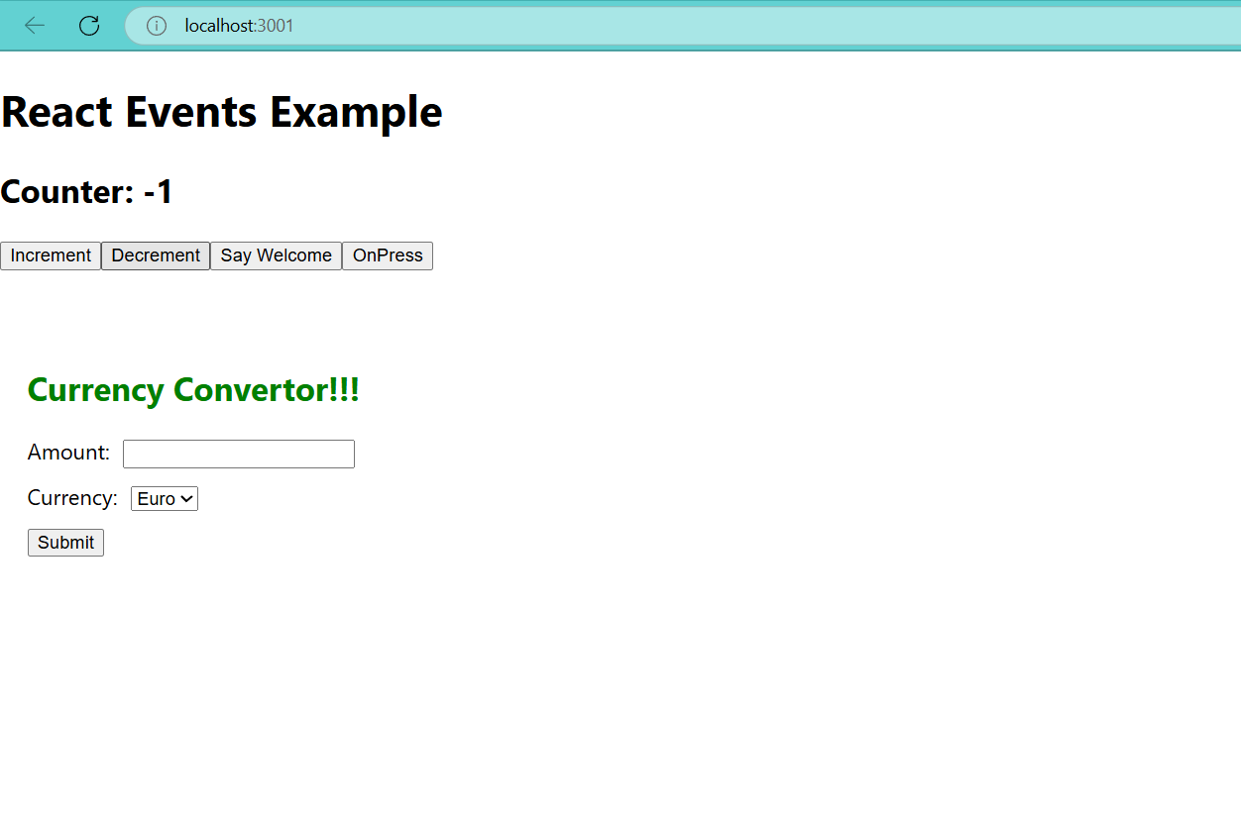

**Say Welcome Button**

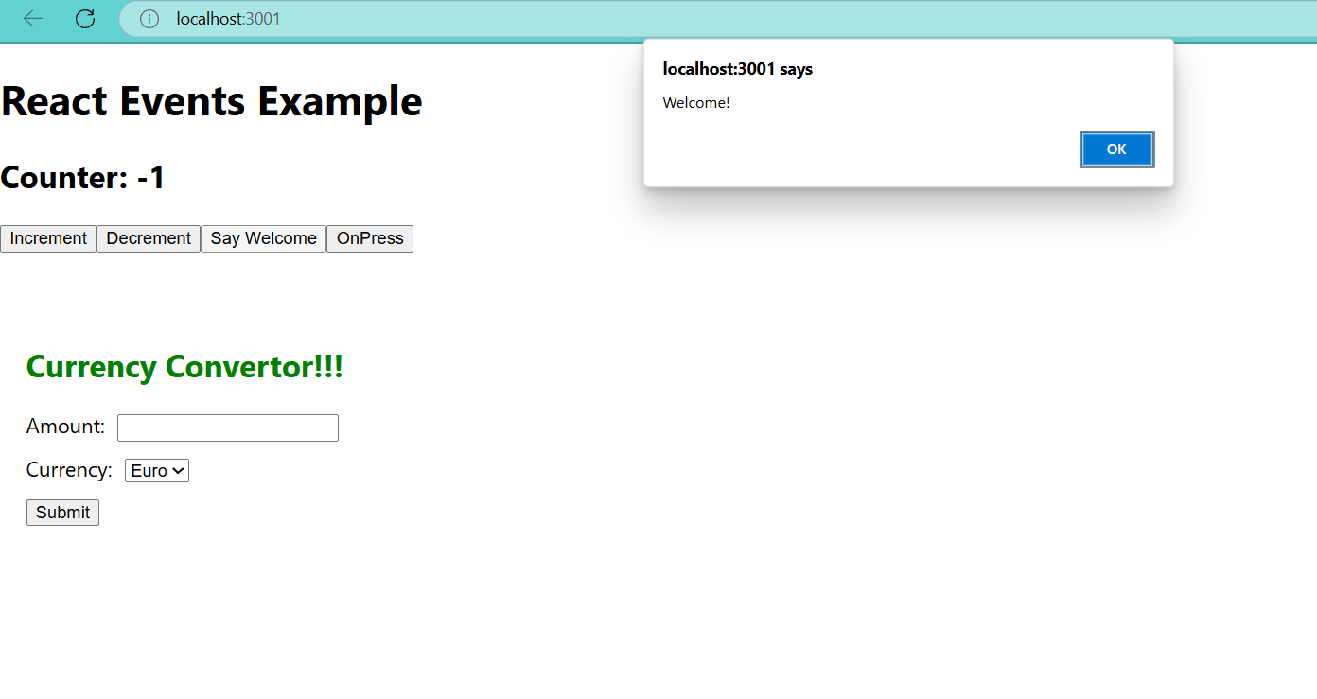

**OnPress Button**

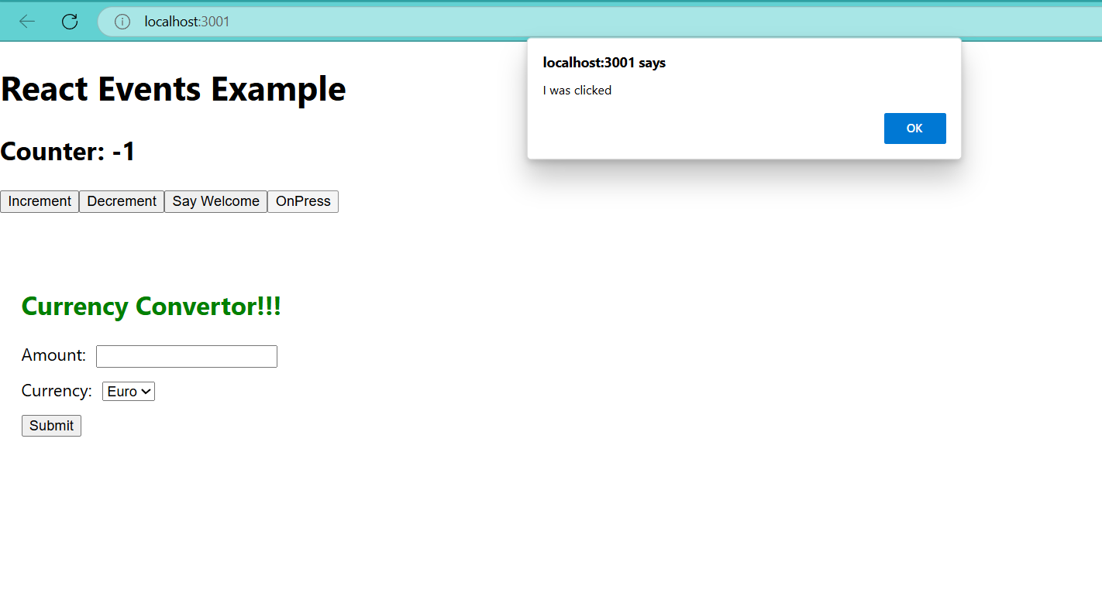

**Currency Convertor Button**

